ERI ANALYTICAL CLOUD SYSTEM (AI)

Technology that enables digital health analysis using Artificial intelligence, Emission Spectroscopy and Biometry. (Picture 1).
It allows also remote examination thanks to SW located in the Cloud.

Picture 1

1.Each organ emits a unique electric field which can be thought of as its electric signature (Picture 2)
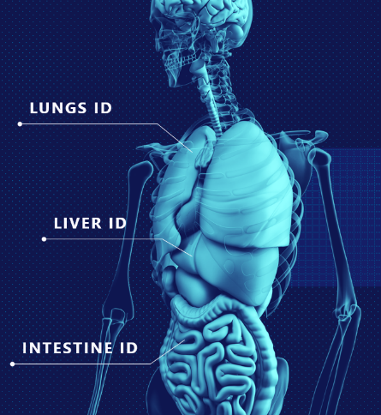

Picture 2
https://www.youtube.com/watch?v=Kc3DpNfFmag

There is an interesting finding that if an organ doesn´t work properly, this electric emission is changed! The same as heart, which is not healthy, gives different electrocardiogram than the healthy one. It means we can use this electric language to identify if the organ is healthy or not (picture 1)

2.The ultrasensitive sensor records a large range of micro-electric waves radiated by objects such as molecules, atoms, and subatomic particles (picture 3 and 4).

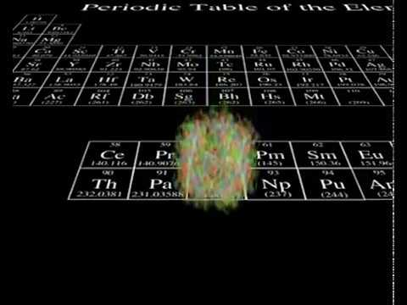
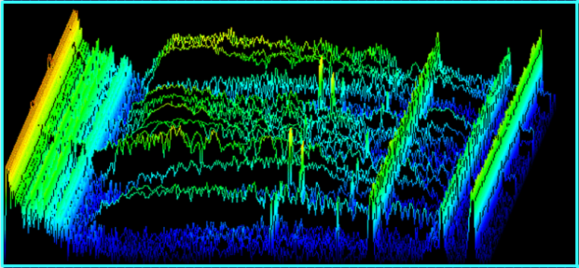

Picture 3 Picture 4
It allows to indetify very unique electric signatures of individual organs, tissues, hormones, enzymes, neuropeptides and other signal molecules in the body. It uses the principle of Emission spectroscopy which utilizes the fact that each element emits a specific electric field based on amount of electrons and protons in its atom. Then everything created from these elements has its own electric signature. https://www.youtube.com/watch?v=LXr0KSbrO3w

3.Subsequently, the process of digitalization takes place (Picture 5). The electric emission of individual organs, tissues, hormones, enzymes etc. is transformed into spectral digital markers. There is applied a Mathematical method Non-Commutative Harmonic Analysis Kazhdan-Lusztig for the Lie symmetry Groups E8 which is called nowadays a new mathematical microscope.

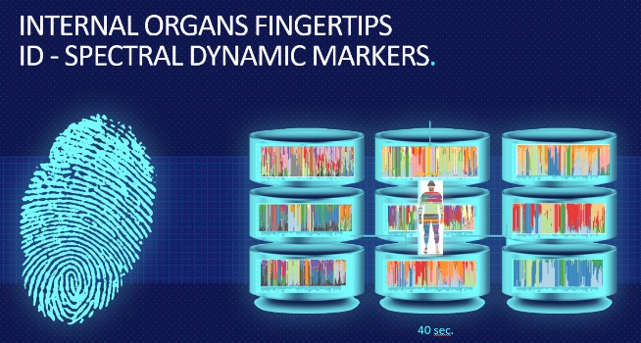
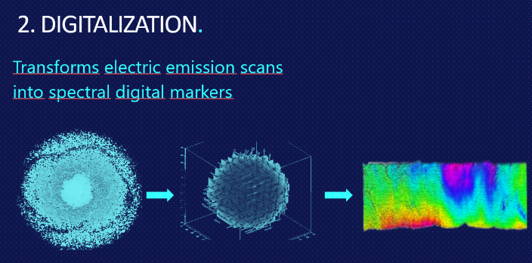

Picture 5 -digitalization of electric emission of organs and signal molecules into spectral digital markers Picture 6

4.Digitalized signal is sent to the computer which has downloaded ERI software from the cloud. In total ERI software contains a database of more than million spectral dynamic markers – where each represents a digitalized information about particular organ in a healthy state. When a patient comes and holds the sensor, it takes 40 sec to measure his million+ markers (picture 6).

5.Artificial Intelligence (AI) is used to analyze the data and to track the pathology (picture 7). ERI is a self-learning software and leverages the technique of Big data analysis to continuosly learn and improve its performance. It means the more data of patients is accumulated the more accurate are the outcomes of the screening. Currently there is approx. 750.000 patients recorded and more than 8 million scans are in the Cloud. It is a huge source of information for AI to analyse data, learn and provide more accurate results.
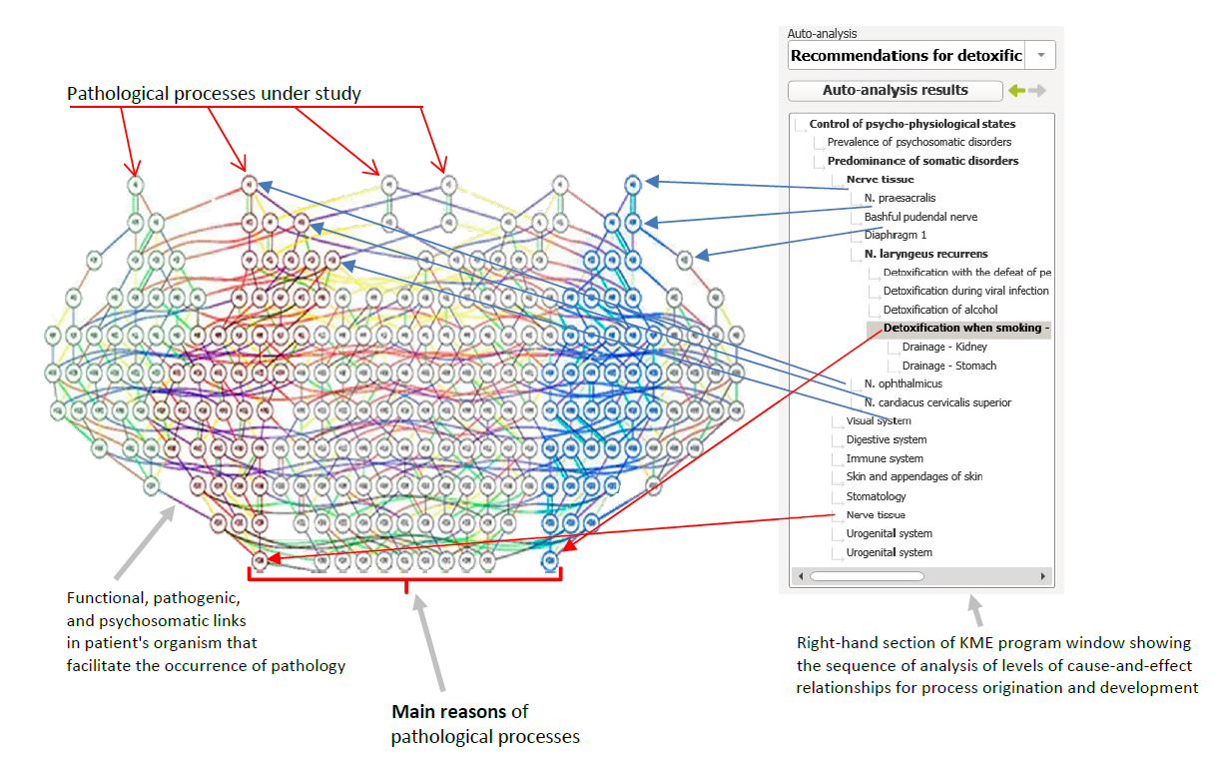
Picture 7

6.The outcome of this digital examination is:
- complete screening of health state- exact location of main pathology- definition of main cause of pathology and its causality.
- screening of mental state - ERI is capable to detect molecules which are released during certain emotional situations -so called neuropeptide, and thus analyze mental state of the person.
- new source of information about personal health condition – ERI® contains more than 1400 000 reference spectral digital markers in the database and the same amount of markers are scanned from the patient. The outcome is complex screening of health condition.
- information about the most critical systems in the body
- location of pathology at organ level of given system
- Toxic load /detection of pathogens/ in the place of pathology
- Information about pathogens (viruses, bacteries, fungi, parasites) and their toxins gives immediate information to doctor about the origin of inflamation and eliminates blind usage of the antibiotics as a first choice.

- Causality between main couse and manifested pathology is allowed due to SW using interface of Artificial Intelligence and big data processing in the cloud.

7. ERI Correction of pathology
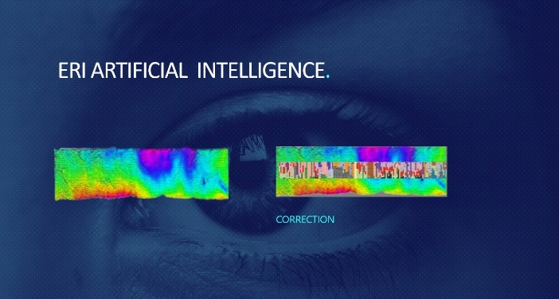
ERI (AI) software knows exactly how some organ/system should look like when is healthy and how it is in reality (see ERI-General prinicples below). If an organ doesn´t broadcast the right signal, ERI software generate a correcting signal (emitted by sensor) which interferes with the place of pathology. Pathology is represented by disruption of synchronous connection (non-locality) and thus the system is loosing the information about its healthy functionality.

Technical implementation of ERI regulatory signal leverages this quantum nature of living systems. The regulatory signal is primarily aimed to restore of non-local connections in the individual quantum systems of the body by restoring their coherent (synchronous) state, thereby recovering the information, communication and regulatory processes between the structural elements within the systems, and in the consequences, between other systems.
ERI technology thus represents the first targeted intervention into quantum level of cells communication and informatics to restore their non-locality (synchronicity) which is carrying the precious information about their physiological state.

Literature:
HIMSS INSIGHT 7.2, Dec.2018, Artificial Intelligence
MAI / Master in Artificial Intelligence, https://www.usi.ch/en/mai?gclid=CjwKCAjwiN_mBRBBEiwA9N-e_iZyUdrPdW-ph6nbNYtl3Upf7NrT8tOJTTBvUt0Oe2JFBBt4QHgn_RoC-dkQAvD_BwE
MIT Technology review, Computing, quantum computing, Jan29, 2019
https://www.technologyreview.com/s/612844/what-is-quantum-computing/
Johnjoe McFadden: The Origin of quantum biology, Dec12, 2018
https://www.ncbi.nlm.nih.gov/pmc/articles/PMC6304024/
Dr. I.Orzhelskyi, Theoretical foundation of physical and mathematical medicine, ISBN 978-5-9906691-3-0
Artificial Intelligence in Medicine, https://www.datarevenue.com/en/usecases/artificial-intelligence-in-medicine
https://quantumxc.com/is-quantum-communication-faster-than-the-speed-of-light/

